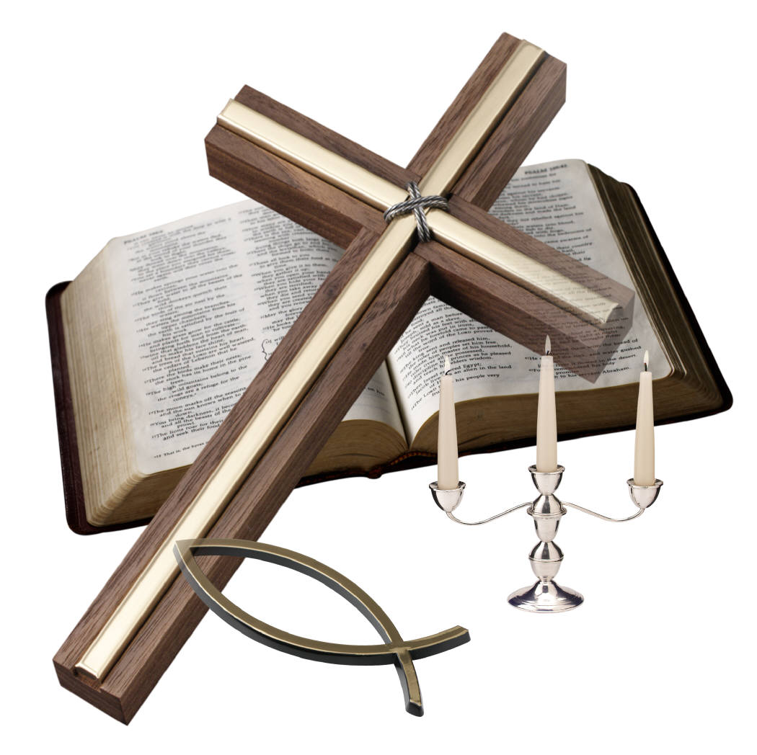
本週經文 Scripture of This Week

靜心聆聽Be Still And Listen
[路加福音10: 38-42]
³⁸ 他們走路的時候，耶穌進了一個村莊。有一個女人，名叫馬大，接他到自己家裏。³⁹ 她有一個妹子，名叫馬利亞，在耶穌腳前坐著聽他的道。⁴⁰ 馬大伺候的事多，心裏忙亂，就進前來，說：「主啊，我的妹子留下我一個人伺候，你不在意嗎？請吩咐她來幫助我。」
⁴¹ 耶穌回答說：「馬大！馬大！你為許多的事思慮煩擾，⁴² 但是不可少的只有一件；馬利亞已經選擇那上好的福分，是不能奪去的。」
[Luke10: 38-42]
³⁸ As Jesus and his disciples were on their way, he came to a village where a woman named Martha opened her home to him. ³⁹ She had a sister called Mary, who sat at the Lord's feet listening to what he said. ⁴⁰ But Martha was distracted by all the preparations that had to be made. She came to him and asked, "Lord, don't you care that my sister has left me to do the work by myself? Tell her to help me!"
⁴¹"Martha, Martha," the Lord answered, "You are worried and upset about many things, ⁴² but only one thing is needed. Mary has chosen what is better, and it will not be taken away from her."

本周背誦金句 Golden Verse Of This Week
耶穌回答說：「馬大！馬大！你為許多的事思慮煩擾，但是不可少的只有一件；馬利亞已經選擇那上好的福分，是不能奪去的。」
"Martha, Martha," the Lord answered, "you are worried and upset about many things, but only one thing is needed. Mary has chosen what is better, and it will not be taken away from her." [路加福音Luke 10: 41-42]

